


Trustee Appointment

Welcome

Protect is a unique charity, whose mission to serve the public interest is encapsulated in the phrase: “Speak Up, Stop Harm”
Organisations of all types, sizes and industry sectors can adopt, often unintentionally, working practices which expose customers, workers and/or citizens to risks of harms such as injury or financial loss.

Sometimes those potential harms can be life-threateningly serious. In many cases workers are aware of and concerned about the risky practices but don’t know how to raise their concerns (ie. how to blow the whistle).
For more than 30 years, Protect has been committed to serving the public interest by making it more likely that actual or potential harms arising in organisations are identified and addressed as promptly as possible. We do this in three main ways:
1. Providing free, confidential and legally-privileged advice to workers to have concerns about practices in the organisations in which they work.
2. Providing advice and training to directors and managers on how to improve the arrangements for workers in their organisations to raise their concerns.
3. Lobbying for changes in the legal and regulatory framework which make it more likely that workers will feel able and willing to raise concerns.
Protect is a small charity, but we make a big impact. We advise over 3,000 actual or potential whistleblowers each. We advise around 300 organisations which employ hundreds of thousands of workers. And the number of people whose risk of exposure to harm is reduced as a result of our efforts will be in the millions.
Whistleblowers play a huge role in society and help keep us all safe from risk, malpractice, and wrongdoing.However, we are conscious that there are many more workers and organisations who could benefit from our advice and we are ambitious to expand our reach so that we can be even more effective in reducing the risk of harm. Protect believes whistleblowing is a good thing, and we need more of it. More employers too, need to be helped to recognise the benefits of staff who speak up and there is much to be done to ensure staff feel safe about speaking up.
The current Chair of our Audit and Risk Committee (‘ARC’) comes to the end of her term in Q2 2026 and as a result we are looking to recruit a Trustee who is qualified to take over as Chair of the ARC.
We are looking to recruit new Trustees who have a commitment to our mission of “Speak-Up, Stop Harm” and who have a range of skills and experience which will enable them to make an effective contribution to our Board.
If you wish to help guide the Protect team into their next exciting phase, we would very much like to hear from you.

Lucy McLynn,
Chair of Trustee

Role description



Location
Our offices are in Bethnal Green, one stop from Liverpool St Station. We hold many hybrid meetings.

Time Commitment
Approximately one day per month. The Board meets five times per annum, usually late afternoon/early evening. Trustees are also likely to be appointed to one of the Board Committees, which meet three times per annum.

Terms
Three-year initial term, renewable twice. Trustees can serve for a maximum of nine years.

Renumeration
This is a voluntary role without remuneration. Travel expenses as well as other reasonable and necessary costs incurred, as part of official Trustee business, will be reimbursed.

Responsibilities

Role Summary Key Accountabilities

Trustees play a critical role in the organisation. They set strategy and review progress, providing support, challenge and expertise to the Chief Executive and Senior Leadership Team. Trustees also have ultimate responsibility for the compliance with legal and regulatory requirements, as well as ensuring that the organisation acts in line with its charitable objectives and is financially stable. They work as a team, applying good judgement and taking collective responsibility.

This current recruitment is for chair of ARC which has specific responsibility for financial oversight.
Protect is committed to achieving greater diversity in its board, and actively encourages Black people and People of Colour, disabled people and young people, who are currently under-represented at board level, to apply. If you would like to be a board member but face barriers in applying such as accessibility issues please get in touch to discuss how we can support you

Induction
A thorough induction process is in place for new Trustees. There will be both formal and informal training available to new Trustees which will include on-going training ensuring board members are up to date on good governance.

- Safeguard Protect’s charitable objectives, activities, and values.
- Understand and ensure the organisation complies with and acts within its powers, as laid out in the governing document known as articles of association.
- Contribute actively to the Board’s role in setting strategy and hold the Executive to account for delivering Protect’s strategic objectives.
- Ensure the financial sustainability of Protect, and that appropriate financial controls and policies are in place and reviewed regularly.
- Ensure there is an effective process in place for monitoring and managing risk.
- Devote the necessary time and effort to develop a good understanding of Protect and its work by reading papers, participating in subcommittees, visiting Protect, and meeting staff, participating in training, working groups and others as required.
- Contribute to and help drive improvements in the Board’s own performance ensuring an effective, high-performing team.

Person specification

The current Chair of our Audit and Risk Committee (‘ARC’) comes to the end of her term in Q2 2026 and as a result we are looking to recruit a Trustee who is qualified to take over as Chair of the ARC.

Responsibilities of the Chair of the ARC

- Chairing the Committee of the Board that has been established to oversee the financial and risk management framework, policies and controls of the charitable company
- Ensuring that the Committee meets with sufficient frequency (at least 3 times per annum), devotes sufficient time and attention to the matters within its remit and receives appropriate management information
- Reporting to the Board on the activities of the Committee and escalating matters/issues as appropriate
- Taking the lead on ensuring the charitable company meets its financial reporting obligations
- Oversight of the relationship with the external auditor and outsourced management accounting function
- Acting as 2nd approver for monthly salary payments and high value payments
- Overseeing the identification of new and emerging risks

Essential criteria (please don’t apply if you don’t meet these criteria)
- Experience of accruals accounting, given the importance of our membership income stream, and of the requirements of the Statement of Recommended Practice on Accounting and reporting by charities.
- Practical knowledge and experience of risk frameworks, including oversight.
- Strong influencing and communication skills, including the ability to effectively chair meetings as well as encourage debate and challenge.
- A record of sound judgement, ability to work with others and apply common sense.
Desirable criteria

- Qualified Accountant
- Experience of the regulatory requirements within financial services businesses for whistleblowing policies, arrangements and Champions
- Understanding of best practice in corporate governance arrangements
- Ability to develop strategy and provide strategic direction
- Experience of fundraising

Expectations of all trustees
To take on the responsibility of the role of Trustee, individuals need to be engaged and motivated in the work and mission of Protect. Commitment, engagement, and reliability are key to fulfilling your responsibility as a Trustee.

- A wholehearted commitment to, and empathy with, the vision, mission and aims of Protect. Passion for protecting the public interest and a belief in the benefits of a “speak up culture”.

- Sound independent judgement, strategic vision, and the ability to think creatively.

- A strong commitment to diversity and inclusion.

- A collegiate approach with strong relationship-building abilities.

- Ability to communicate clearly and sensitively and to take an active part in discussions.

- A willingness to ensure that people work well together on the Board, to express your opinion in a reasoned way, while also listening to the views of others.

- Honesty and integrity, a commitment, willingness, and ability to act in the best interests of the charity at all times.

More about Protect

Who we are

We aim to stop harm by encouraging safe whistleblowing.

Back in 1993, when our charity, then called Public Concern at Work, was set up, whistleblowing was viewed very differently. Whistleblowers were largely seen as loners, mavericks, and even trouble- makers. And the idea of corporate whistleblowing functions, with staff employed in roles dedicated to whistleblowing, was light years away.

A series of disasters and scandals, including the capsizing of the Herald of Free Enterprise, the explosion at Alpha Piper oil rig, the Clapham Rail Crash, and
the pillaging of the Mirror Group’s pension fund had rocked the UK. Exhaustive public inquiries highlighted workplace cultures were a serious part of the problem and revealed staff were often aware of dangers but felt they could not raise the matter internally. People did not feel it right, safe or acceptable to challenge malpractice, risk or misconduct in their workplace.

We wanted to show the link between whistleblowing and accountability and to break the culture of cover-ups and complacency.

Today, scandals, of course still happen, as we have seen with the Mid Staffs Hospital inquiry and the recent deaths at the Countess of Chester hospital, Oxfam
sex for aid, and sexual misconduct in Parliament, but there has been a definite sea-change in attitudes towards whistleblowing. Through our work, we know there is still much to be done.

Sometimes whistleblowing is called “speaking up” or “raising a concern”. It is all about ensuring that if
someone sees something wrong in the workplace, they are able to raise this within their organisation, to a regulator, or wider.
Whistleblowing ultimately protects customers, staff, beneficiaries, and the organisation itself by identifying harm before it’s too late.

Our vision is of a world where no whistleblower goes unheard or unprotected.

Our mission is to protect the public interest by helping workers to speak up to stop harm and wrongdoing. We support whistleblowers by providing free and confidential legal advice. We support employers to implement effective whistleblowing arrangements. We campaign for legal and policy reform to better protect whistleblowing.

Our values are: supportive, independent, expert and collaborative.

We have advised around 60,000 people on our free, confidential advice line, trained thousands of managers, senior managers and board members and currently support hundreds of organisations to strengthen their internal whistleblowing or ‘speak
up’ arrangements. We were closely involved in setting the scope and detail of the Public Interest Disclosure Act more than 20 years ago and we are campaigning for new whistleblowing legislation which will better protect more individuals and put the onus on employers to do more to protect employees who speak up to stop harm.

For more details of how we provide advice and support and our campaigning, visit our website

Our impact in 2024

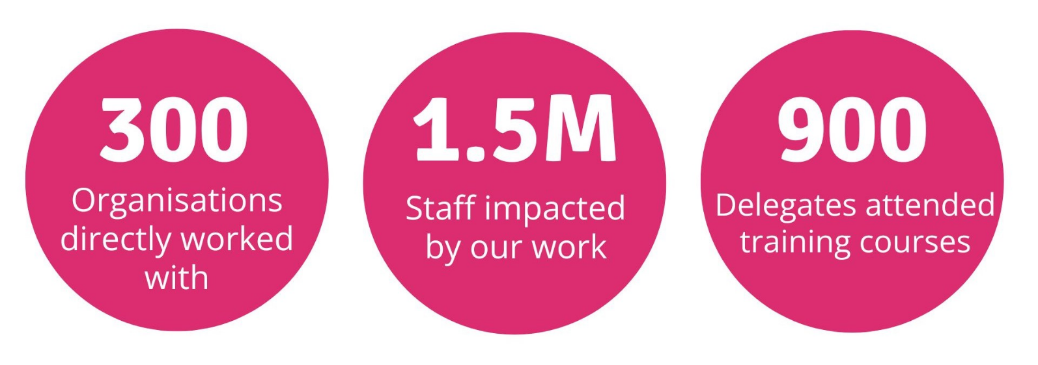
'
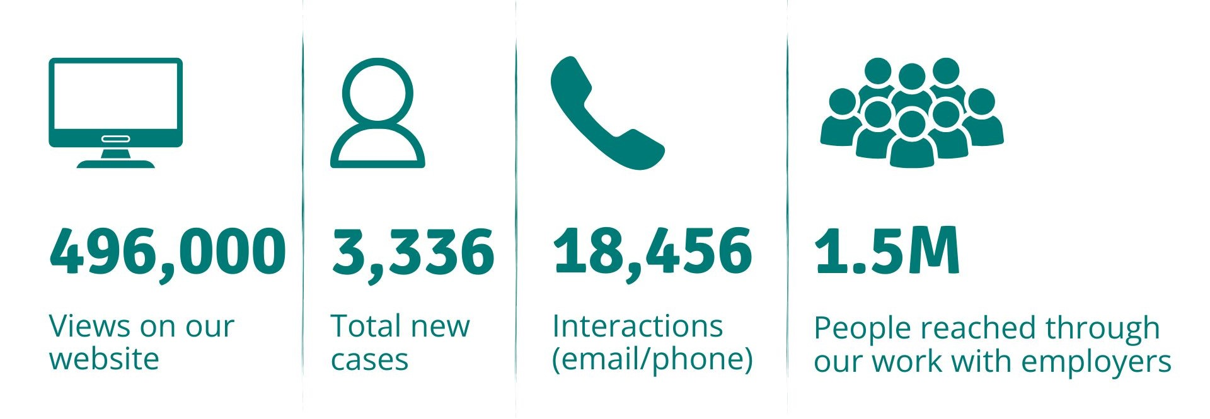

Our impact

We are proud of the difference we make. In the 30 years since we were established we have had many successes to celebrate in the development of the legal framework for whistleblowing including:

- Drafting pioneering legislation on whistleblowing
-the Public Interest Disclosure Act 1998 which has been used as the model for legislation across the globe.

- Intervening in landmark Court of Appeal and Supreme Court cases leading to further
amendments to the law, for example extending the definition of worker and defining the public interest test.

- Influencing the introduction of whistleblowing policy development in many sectors including financial services and the NHS and the development of an EU Whistleblowing Directive.

The 360 Benchmark enables us to identify where we need to improve, and identify the key actions that we need to carry out in order to improve, but also to obtain assurance in those areas where we are performing well.
“
It is essential that the public trusts those organisations that spend money on their behalf and has confidence in their ability to identify and deal with wrongdoing. A key part of this
is to ensure that there are processes in place to encourage staff and others to raise their concerns in a safe environment. Protect play a vital role in giving organisations the tools to do this: their new benchmarking service has enabled us not only to identify where we can improve our whistleblowing arrangements, but also to demonstrate where we
are performing well.

Our work spans across a broad range of sectors and our diverse client list includes ITV, Lloyds Bank, KPMG, Durham University, British Red Cross, Charity Commission, Newcastle under Lyme Borough Council and Marie Curie, to name a few.

Our advice line gives us the opportunity to gain a deep insight into the scale and types of concerns of those working in the various sectors.

The profile of whistleblowing has never been higher, but the challenges in protecting whistleblowers or bringing legal action are many and complex. Our services are crucial as they assist individuals in navigating the law and regulatory landscape, but the law also needs to change to keep pace with the changing workplace. To learn more about our impact, please visit our website.

Simon Bleckly, Audit and Counter Fraud Manager, Corporate Services, Warrington Borough Council

do this: their new benchmarking service has enabled us not only to identify where we can improve our whistleblowing arrangements, but also to demonstrate where we
are performing well.Finances

Income 2024
£1,085K
Donations & legacies: £30,817K

Grants: £115K
Expenditure 2024
£1,044k Staff costs: £877K
Premises: £51K

We are a largely a self-funded organisation, with most of our income generated by employer membership of Protect and our consultancy and training work. However, we were delighted to have the support of four charitable foundations in 2024, allowing us to campaign for legal reform, to build our policy network, to encourage better workplace practices among employers, and to keep our vital advice service functioning.

Despite setting a deficit budget, the charity exceeded its income target in 2024 and ended the year with an operating surplus of £41,844. We have invested in public affairs consultancy and fundraising.

Organisation chart
Communications officer

Governance
Business Sales Executive
Committees of the Board
Audit & Risk
Karen Jordan (Chair),
Julia Graham, Lucy McLynn, Steve Murdoch, Gayle Sparkes
Remuneration
Damien O’Flaherty (Chair), Lucy McLynn, Mallary Gelb, Rebecca Lloyd
Chair of Trustees Lucy McLynn
Trustees
Damien O’Flaherty
Julia Graham
Rebecca Lloyd
Karen Jordan
David Widdowson
Mallary Gelb
Gayle Sparkes
Steve Murdoch

How to apply

Recruitment Process
To apply to become a Trustee of Protect, please send a CV (maximum of 2 pages of A4) together with a supporting cover letter (maximum of 1 A4 page) that fully addresses the skills and experience you would bring to the Board, your specific interest in Protect and why you are interested in the role of Trustee.

We expect the interviews to be held virtually. If you will require any special provision as a result of any disability should you be called for interview, please do let us know. Finally, please ensure that you have included your contact number and email address, as well as any dates when
you will not be available. We will be reviewing applications on a rolling basis.

Please send your application before midday on Monday 16
March to recruitment@protect-advice.org.uk





